**Assignment – 2**

• Connect to the Store Sales Data and do the following: -

**− Remove all the blank rows.**

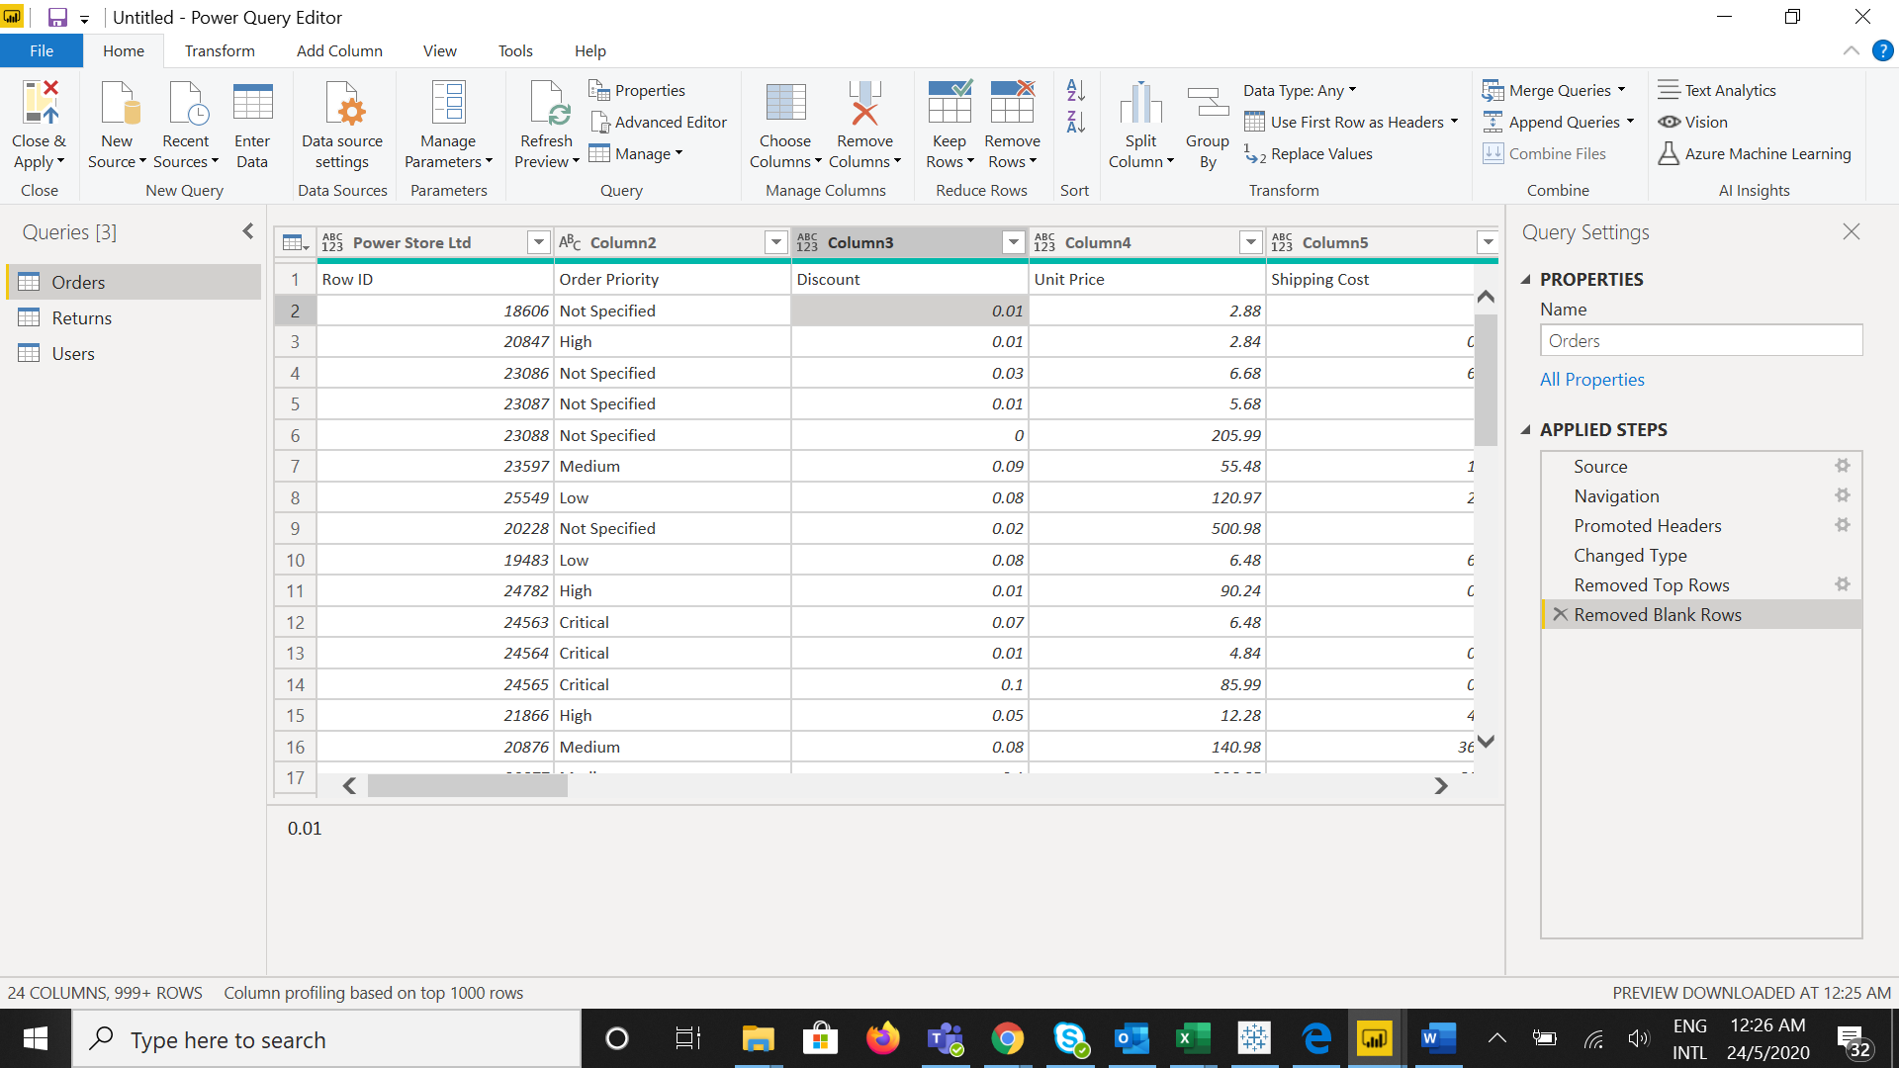

**− Update the column header if they are not updated**

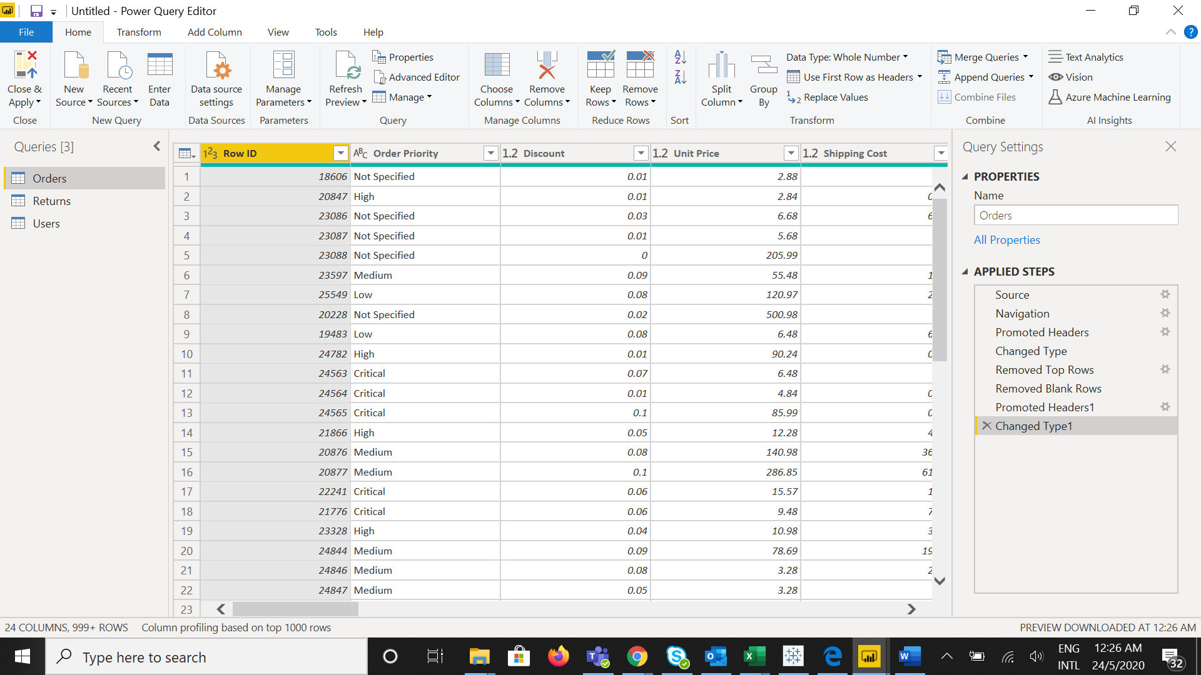

**− Create a text table and show the sales in terms of**

o Customers

o Product Category

o Regions

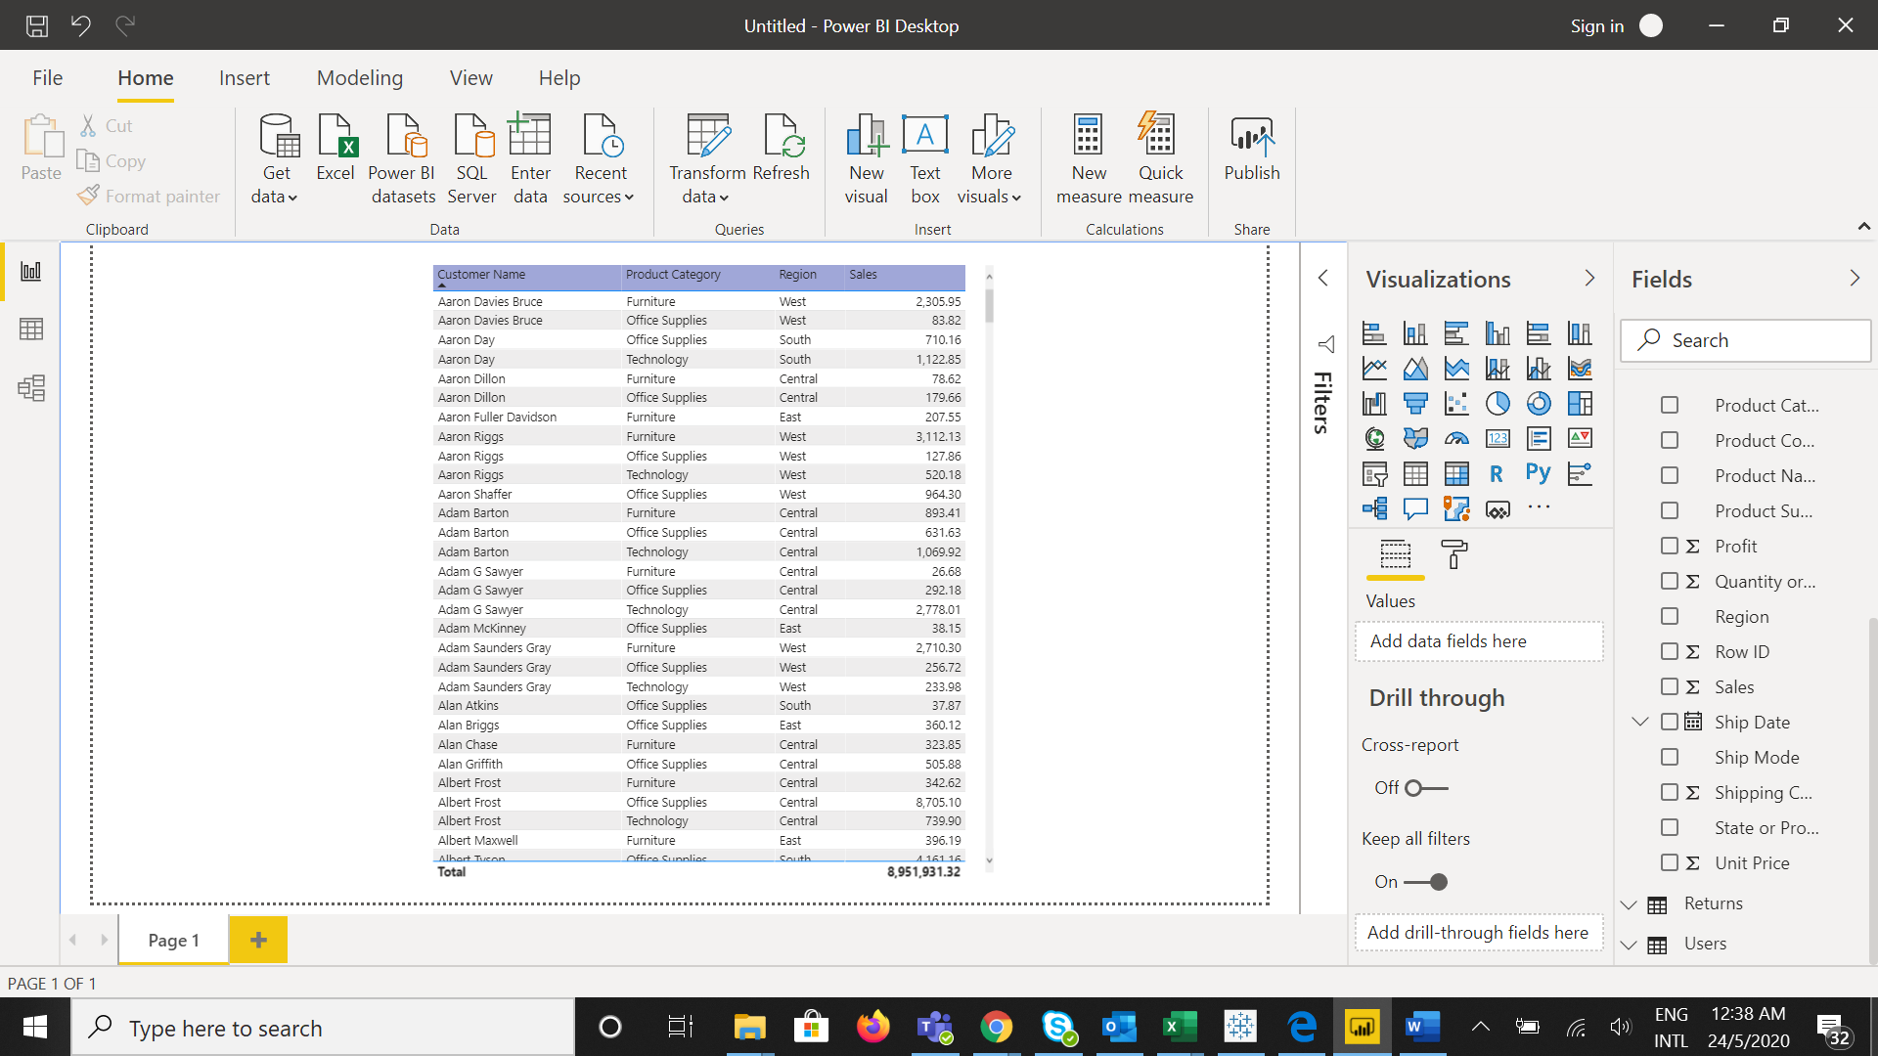

• Create a line and Clustered Column Chart showing the Sales and Discount as per the State or Province

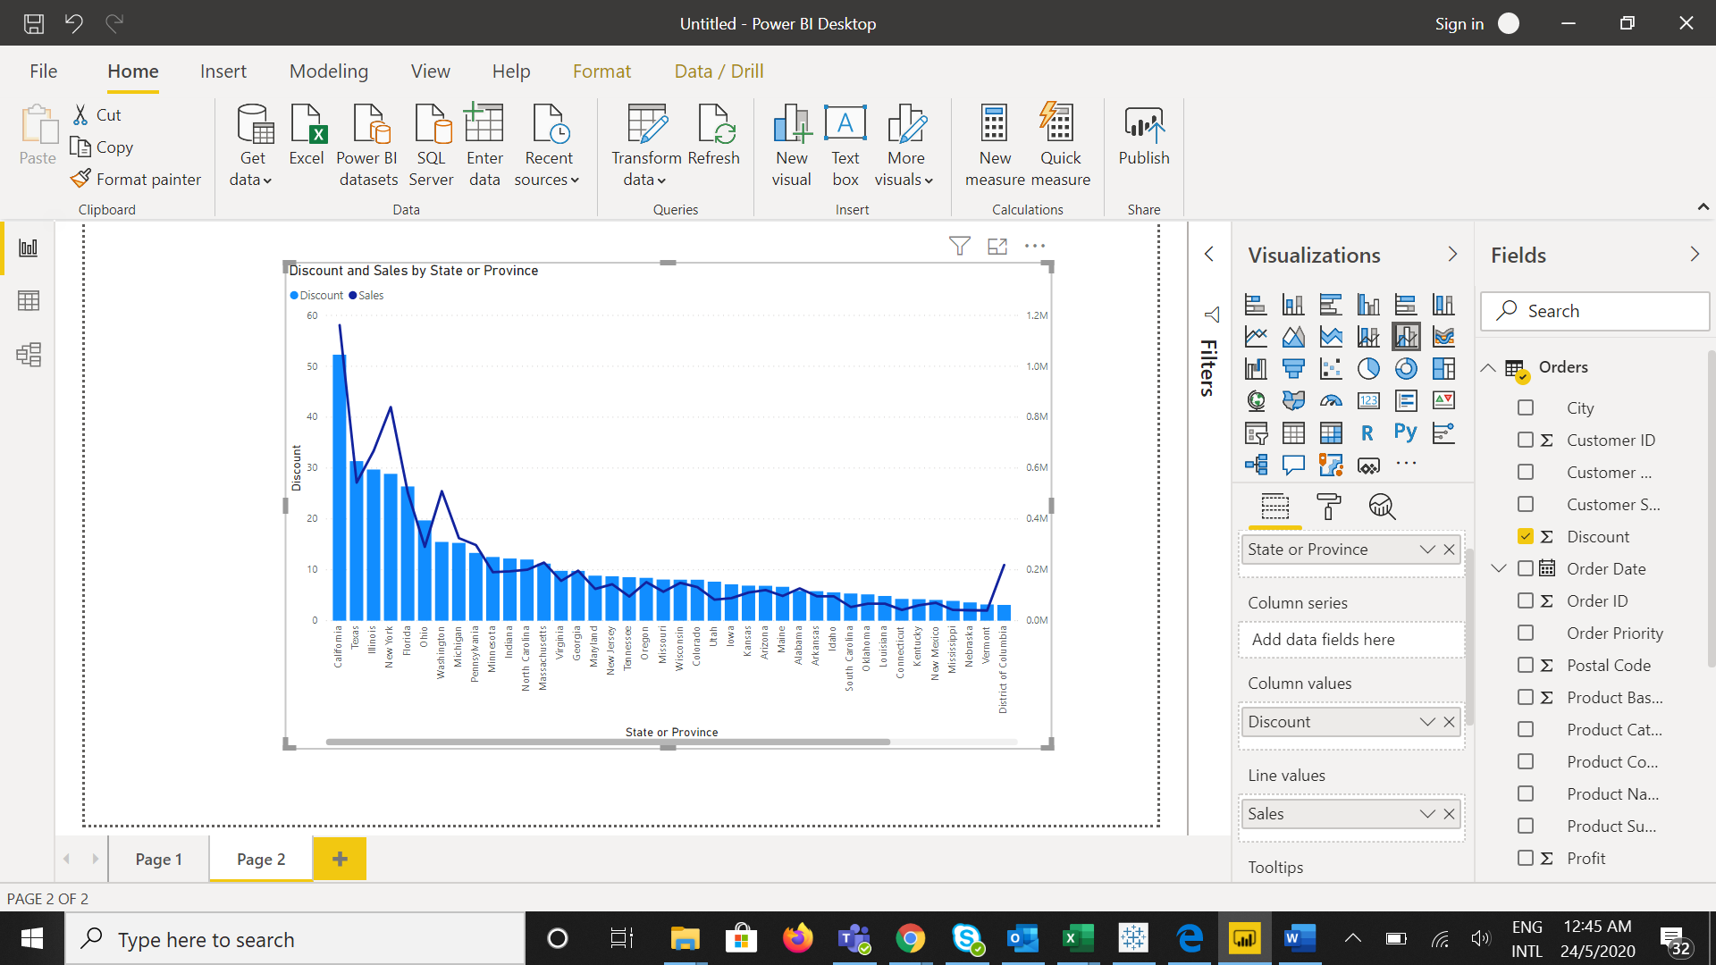

**− Format the bars and line with different colors**

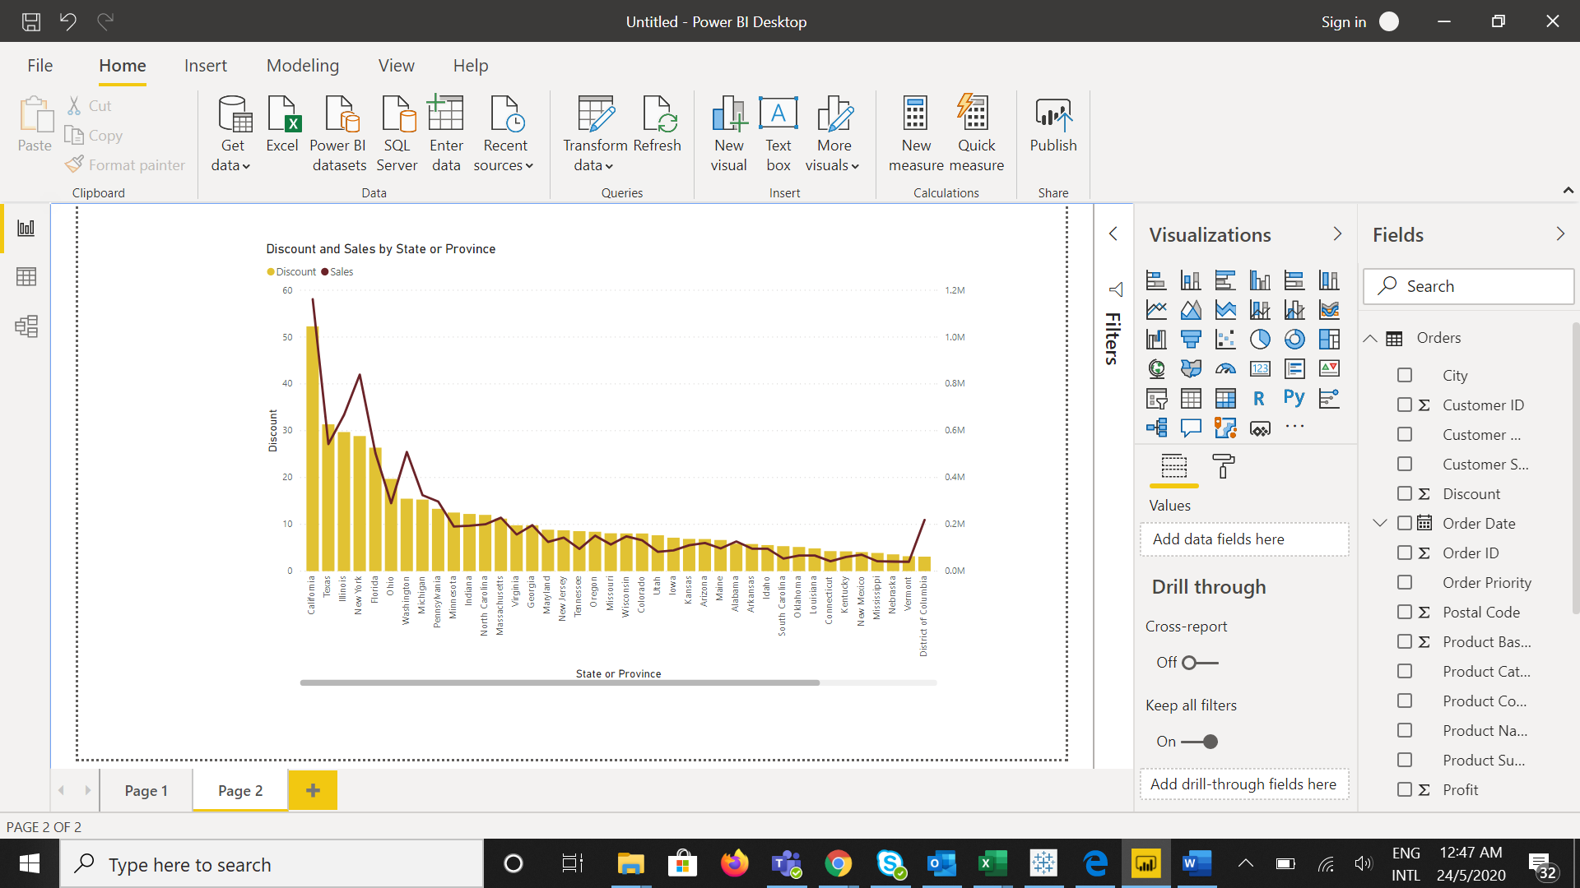

**− Which state has the highest sales in terms Technology**

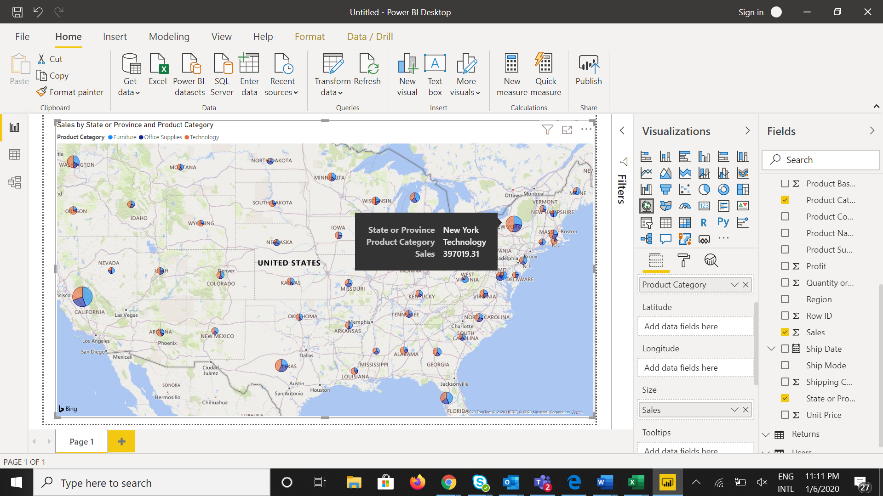

• Create a Donut Chart showing sales in terms of Product category

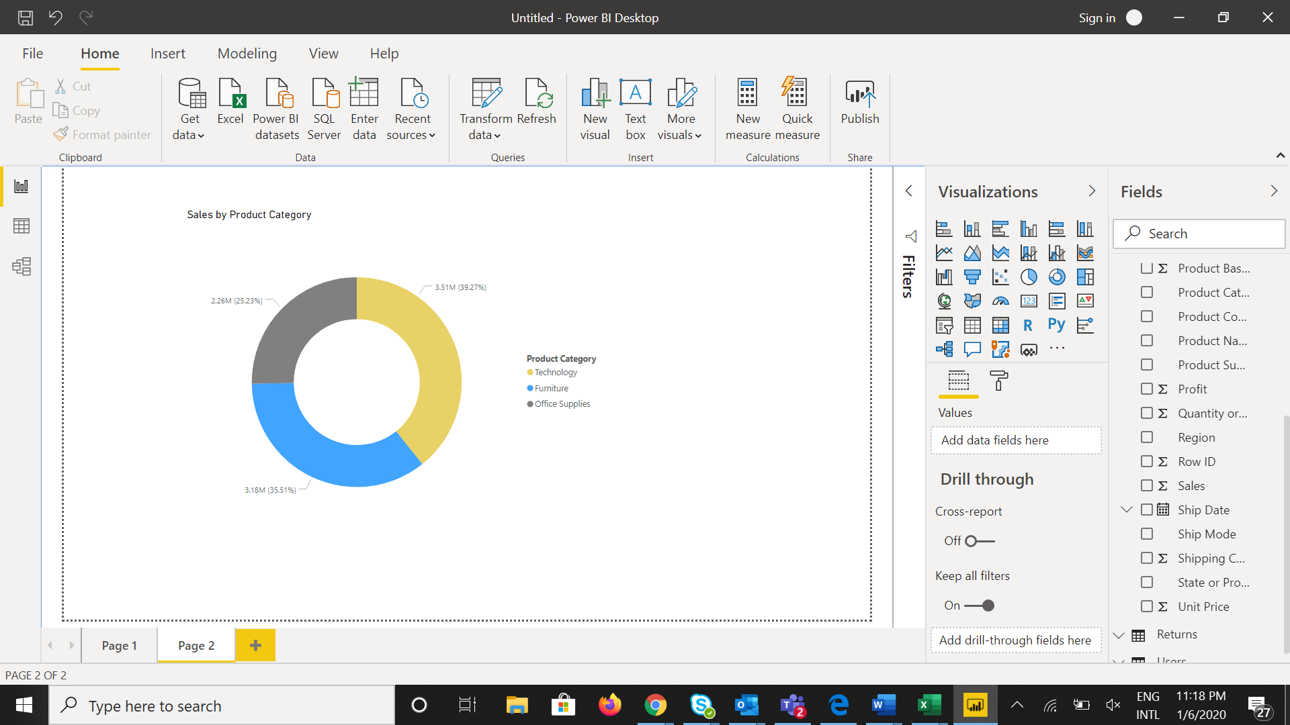

• Create a Slicer and show the regions in dropdown. See how all the visuals mentioned above behaving when a particular region is selected.

Slicer with regions dropdown:

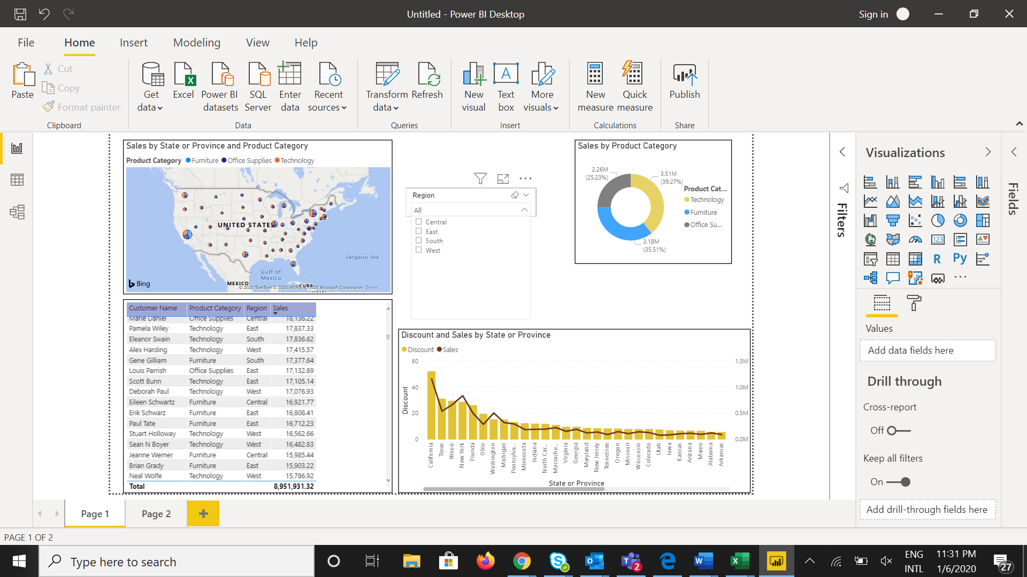

Visuals when selecting Particular regions:

*East*

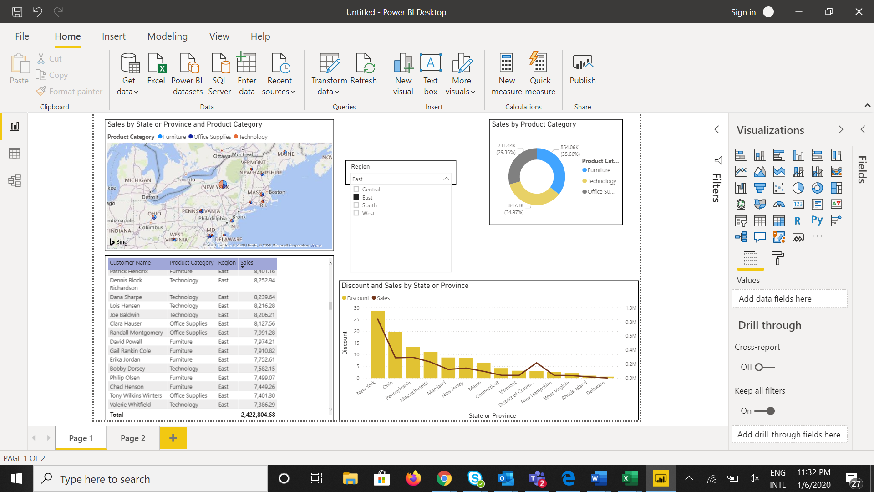

*South*

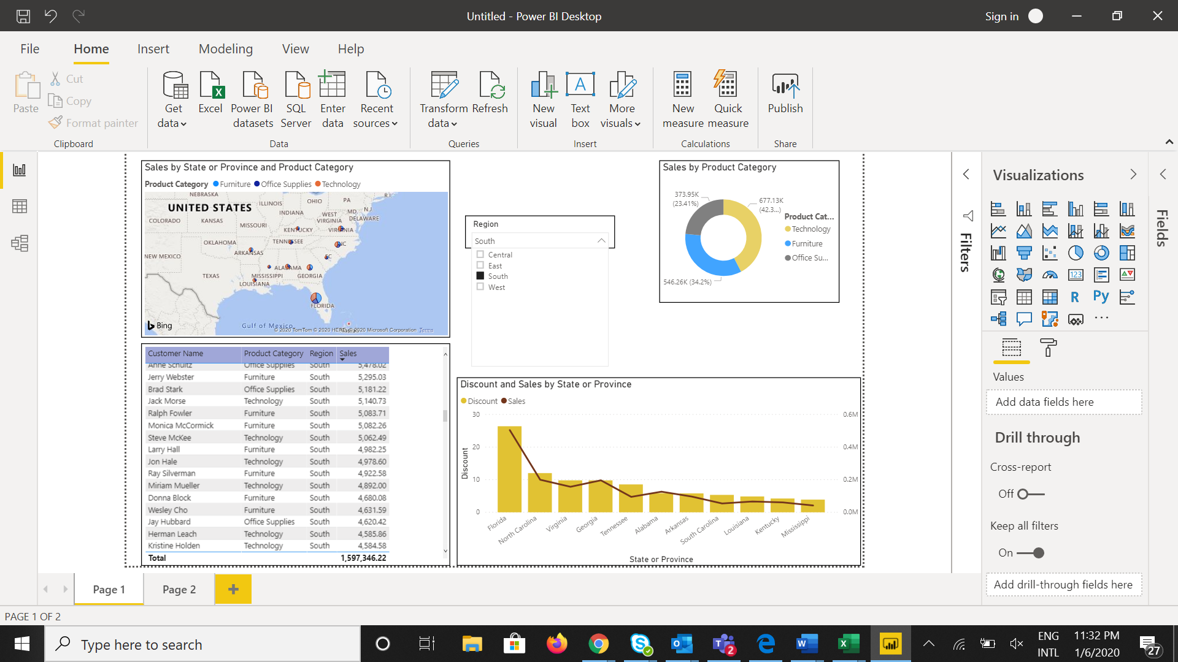

*West*

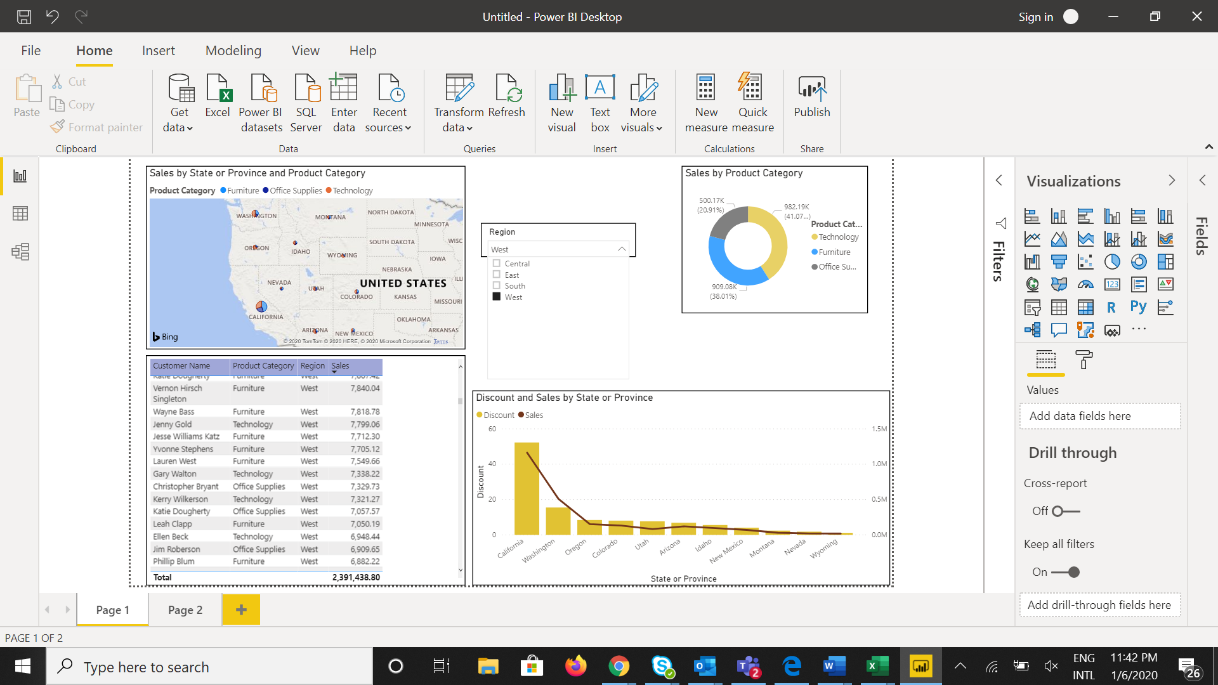

*Central*

